SECOND PRIZE WINNER MR.HRUDHANANDHA BHOI’S SOLUTION
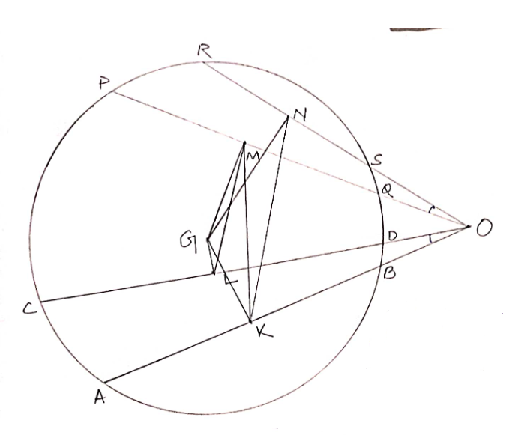
Given : O is a point outside the circle. $\overline{AB}, \overline{CD}$, $\overline{PQ},\& \overline{RS}$ are 4 chords of the circle. K,L,M,M are midpoints of $\overline{AB}, \overline{CD}$, $\overline{PQ}, \& \overline{RS}$ respectively and $m∠LOK=m∠MOK.$
Claim : $\overline{LM} ∥\overline{KN}$
Construction :
$\overline{GM},\overline{GN},\overline{GL},\overline{GK}, \& \overline{MK}$ are constructed where G is the centre of the circle.
Proof:
K,L,M,N are midpoints of $\overline{AB}, \overline{CD}$, $\overline{PQ},\& \overline{RS}$
$⟹$ $\overline{GK}⊥\overline{AB}$, $\overline{GL}⊥\overline{CD}$, $\overline{GM}⊥\overline{PQ}$, $\overline{GN}⊥\overline{RS}$
$⟹$ $m∠GKO=m∠GLO=m∠GMO=m∠GNO$ = 90$°$
As$m∠GMO+ m∠GKO= m∠GNO+ m∠GKO$ = $m∠GNO+ m∠GLO= m∠GMO+ m∠GLO$ = 90$°$+ 90$°$ = 180$°$
G, M, O, K are Cyclic & G, N, O, K are cyclic and G, N, O, L are cyclic & G, M, O, L are cyclic. We can draw only one circle through three non collinear points. So, all these points are on the same circle.
$⟹$ K, L, G, M, N, O are on the same circle
$⟹$ $m∠LGK=m∠LMK=m∠LOK and m∠MKN= m∠MON$
$⟹ m∠LMK= m∠MKN$ (as $m∠LOK= m∠MON given)$
$⟹$ $\overline{LM} ∥\overline{KN}$ -------------------- Proved.

